**KYC VERIFICATION FOR EASISEST REGISTRATION**

**Go to CDSL India site-https://www.cdslindia.com/index.html**

**Quick Links🡪KYC Verification**

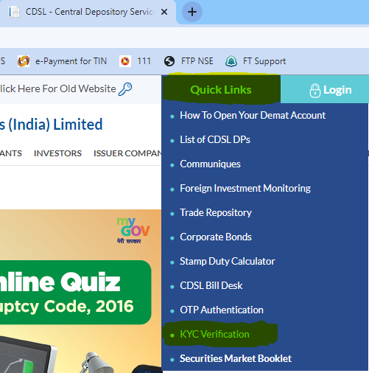

**Enter PAN No🡪Demat Account (BOID)🡪click on Validate🡪Click on generate OTP On Mobile**

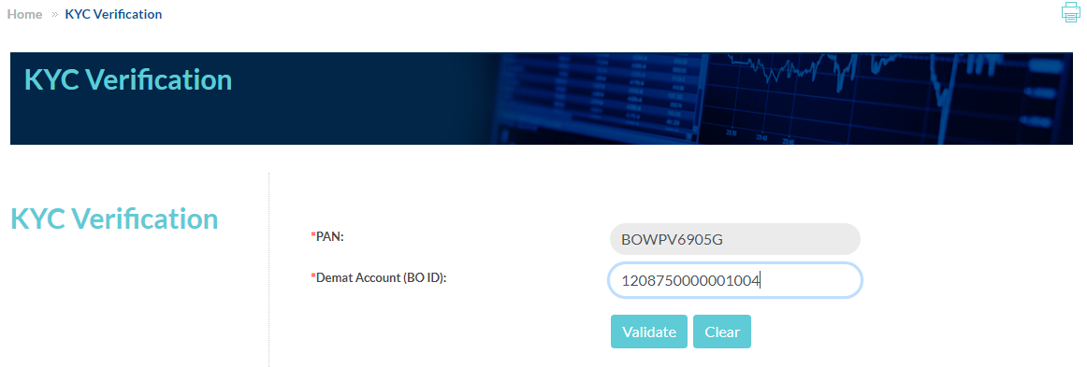

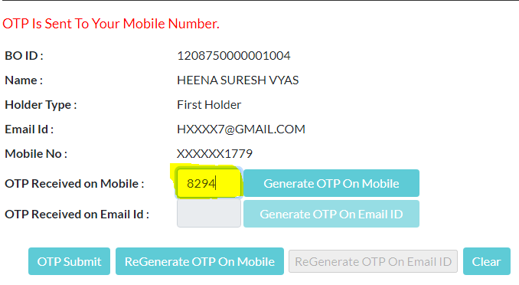

**Click on generate OTP on Email ID🡪OTP Submit**

