

**Registration Procedure for CDSL Easi/Easiest:**

# Step 1: Registration for CDSL Myeasi App

1. **Download CDSL Myeasi app from Google Playstore Or iOS.**

** App logo for easy identification in Play Store**

1. **After Download Select Easi Registration in App for new Registration (Marked in Black)**

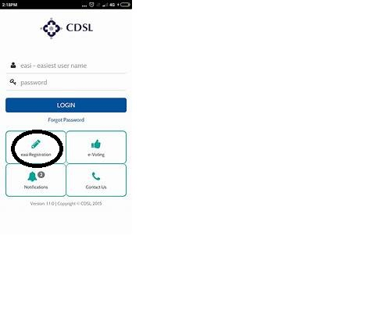

1. **Enter your 16 Digit Demat Account Number**
2. **Enter Pan Number+DDMM (Date of Birth) (only date and month not year)**
3. **An Otp will be received on the registered mobile number from CDSL**
4. **Please Read Terms and Conditions and Select I Accept option.**
5. **The app will ask you certain other details to enter like username, Security Questions etc.**
6. **Afterwhich you have to set password which should be Alphanumeric and between 8-16 characters (No Special Character required)**
7. **By this Your Registration Is Successful and you can login in your app (Things to remember your User Id & Password)**

# Step 2: Upgradation of BOID to Easiest

1. 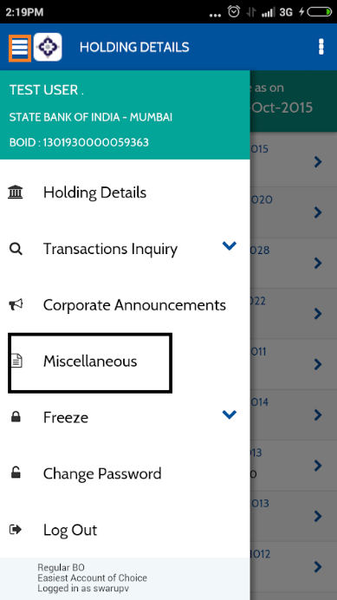**Select Miscellaneous option (In Black Colour Box) from left side 3-line Icon (In Red Box)**
2. **Select Upgrade BOID to Easiest Option**
3. **Select Upgrade Request**
4. **In it there will be two option i) Trusted Pin ii) Digital Certificate,**
5. **Here, We Have to select Trusted pin Which will be received on registered mail of that Client after adding trusted account i.e. (Step 3)**

## Note: PIN Is Important one should remember it after change as it will be used for transaction Process

## Your Status Will be shown as Pending For that Contact DP at HO for Authentication

# Step 3: Trusted Account Addition

1. **After Authentication for easiest we have to add Our Pool Account details.**
2. **For that, Select Miscellaneous option from left side 3-line Icon**
3. **In which Select Edit Trusted Account**
4. **Provide Pool Account BOID i.e. (1208750000001671)**
5. **Get it Authenticated By DP.**

**Note: Once the trusted account gets added the PIN will get generated. It will take 1-2 hours for the pin to generate which will be received in your mail id.**

* **Once received the client has to change the pin**
* **For pin change ,Select Miscellaneous option from left side 3-line icon**
* **In which select change pin option and change it. (Remember the pin should be Alphanumeric no special characters required)**

**One has to mail the DP regarding addition of details and authentication for**

**Mail id: Dp@kediacapital.com**

# Step 4: Early Pay in Setup

1. **Select Transaction Setup option from left side 3-line Icon**
2. **In which Select Early Pay in Setup Option**
3. **There Select Exchange (National Stock Exchange)**
4. **Select Market Type (Rolling Normal)**
5. **Select Settlement ID**
6. **Select CM ID**
7. **Click on get BO Detail**
8. **Select ISIN in which one has to Transact**
9. **Select Quantity of that Particular ISIN**
10. **Select Commit Option to complete the process**

## Note: Details Marked in Yellow should be considered as Compulsory details which should be selected as per given Criteria.

### One Can refer this link for App Registration Process( **<https://youtu.be/1EH4XriTL2Y>** )