**Date – 04-03-2021**

**Approval for the application of modification of beneficial owner through our online web portal**

**For Email Id & Mobile Number Modification Request**

Process for change Email Id in beneficial owner:

We have clients back office web portal for change Email Id & Mobile number

* Login to the kedia back office system <https://kediacapital.webappreports.com/login.php>
* Select the request tab 🡪 Account modification

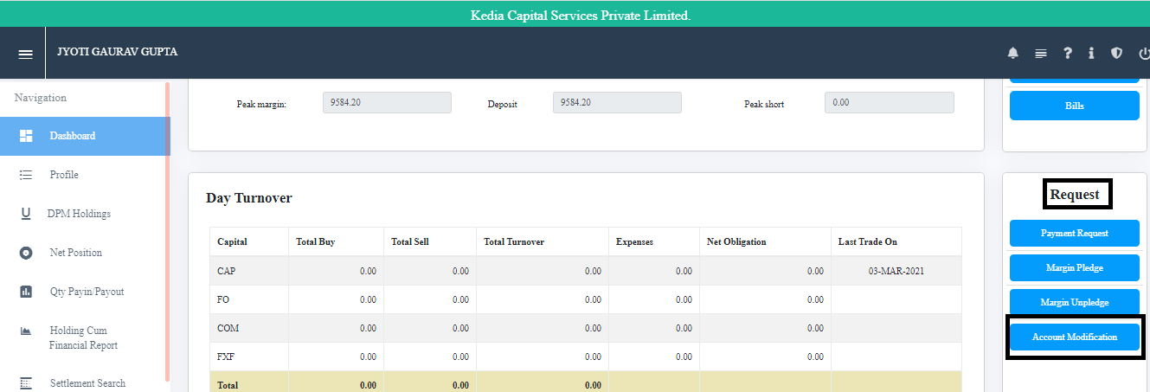

* Select option for change Email Id 🡪 tick on Email Id and Enter new Email Id🡪upload modification form and send the data to back office.

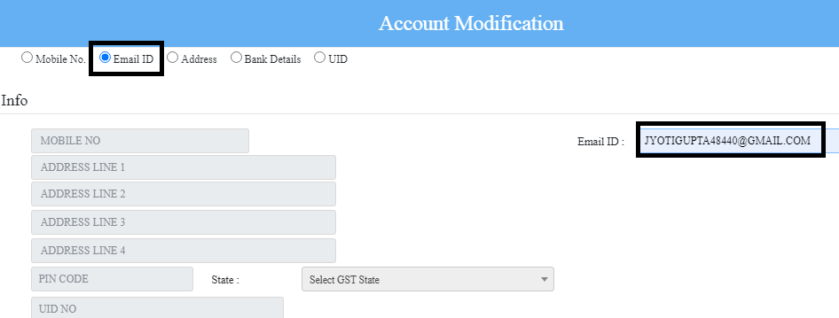

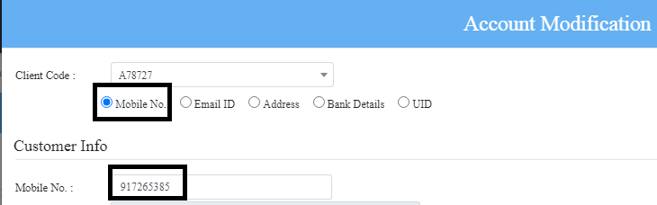

* GET OTP: Click on Get OTP, Client will receive the OTP on your registered mobile no. then enter the OTP and click on send

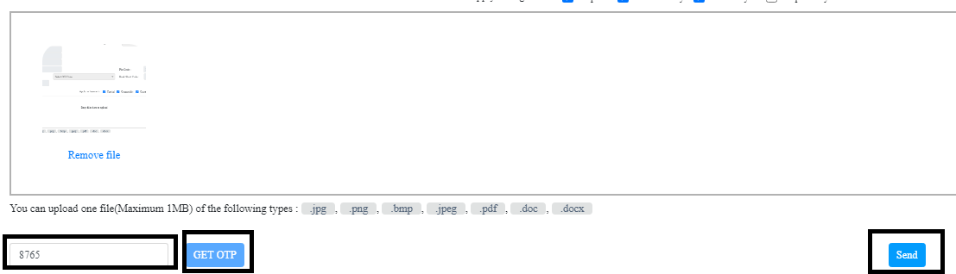

Request will receive to DP and back office team.

DP executive will verify and process the request and the same will modify in back office system and KRA.

Thanking you & Regards

For Kedia Capital Services Pvt Ltd