**BSE Redemption pay-in from through easiest System**

**Steps to** BSE Redemption **for BO:**

1. Login to the easiest system using his EASIEST login details
2. <https://web.cdslindia.com/myeasi/home/login>
3. KEDIA BOID – 12087500-00016494

## BO has to login to the easiest system using his EASIEST login details

* + Visit to CDSL’s Website : <https://www.cdslindia.com/index.html>
  + Click on **Login** Tab at the Top right end side

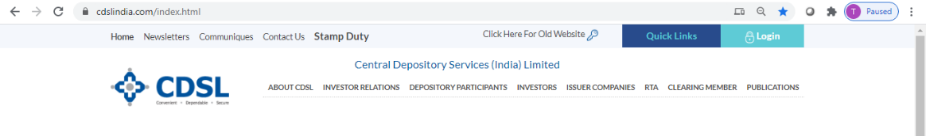



Enter Easiest USER Name and **Password**

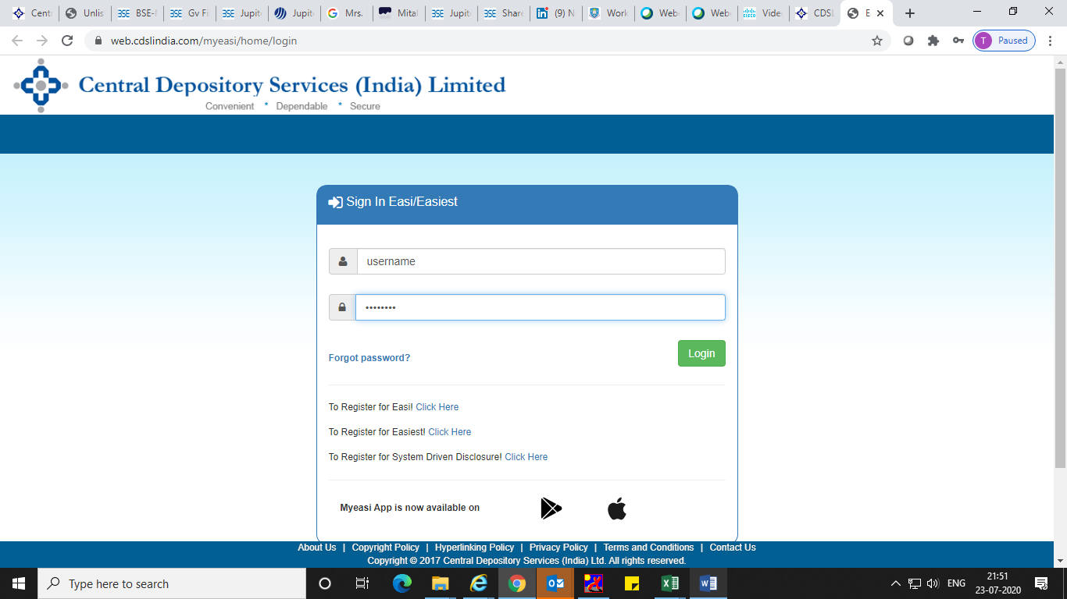

## Click on **Transaction🡪setup menu** in your Easiest login

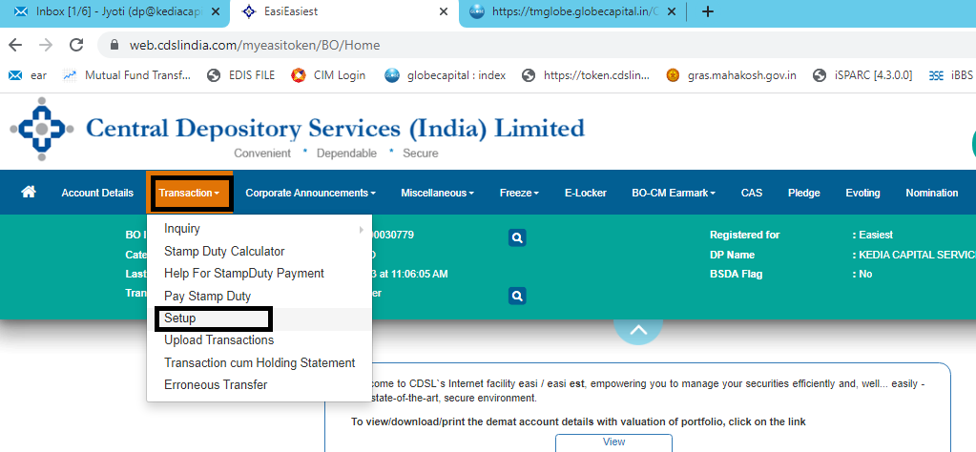

Click on **bulk setup** for pay-in🡪Settlement

* Exchange🡪Bombay Stock Exchange
* Market Type🡪MF Repurchase
* Settlement ID as per Redemption date
* CM ID🡪6713
* Entity Identifier🡪TM

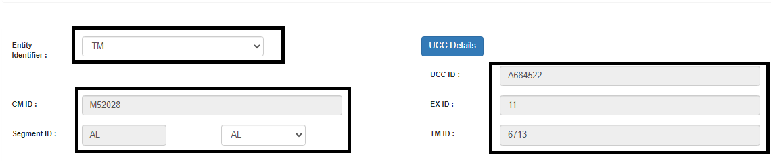

* **Click on Add (+) Button.**
* **Provide ISIN details and Pledge quantity and Value & Click on OK**
* **Submit🡪Click on verify🡪enter PIN and verify**

