**Easiest Registration Process for all clients**

Login to the easiest system using his EASIEST login details through below mention CDSL Website are https://web.cdslindia.com/myeasitoken/Home/Login

## BO has to login to the easiest system using his EASIEST login details

## Visit to CDSL’s Website: <https://www.cdslindia.com/>

## Click on Login Tab at the Top right end side🡪My Easi New (Token) 🡪Login

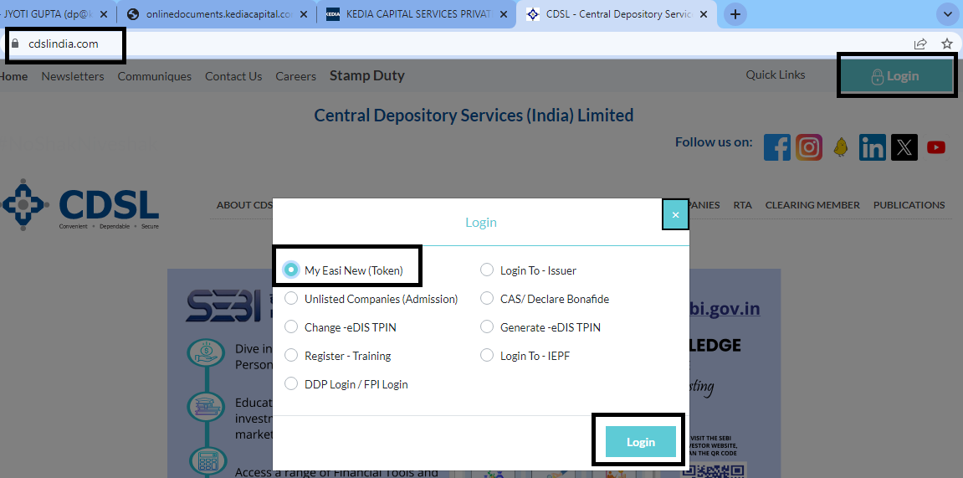

Click on Register for Easiest Login

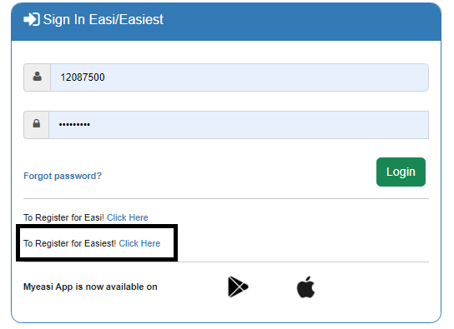

Enter DP ID and Client ID (16Digit)🡪Continue🡪Enter OTP

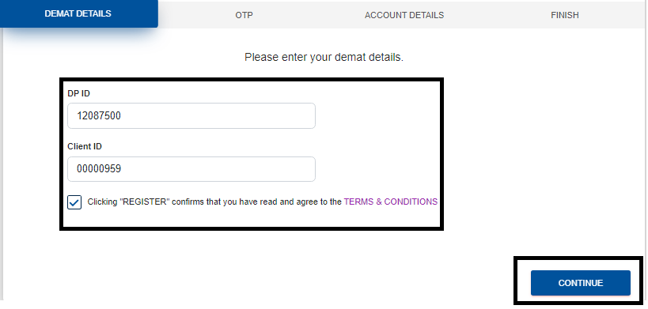

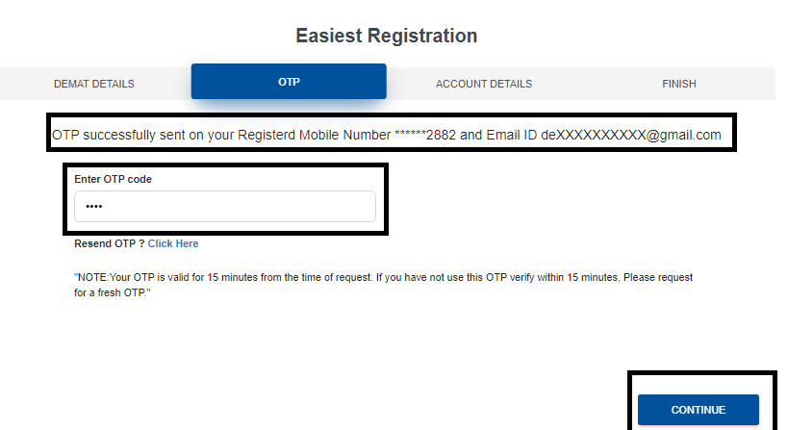

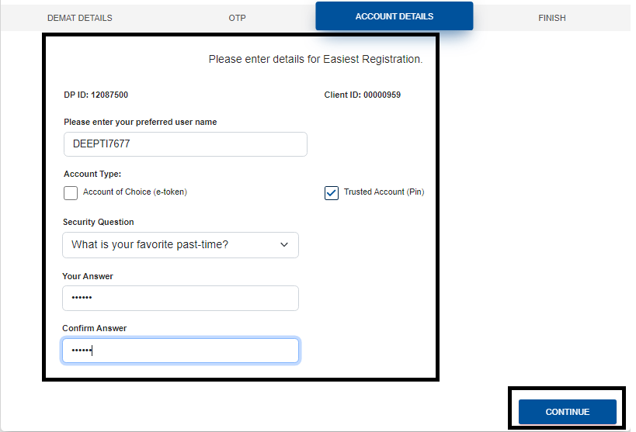

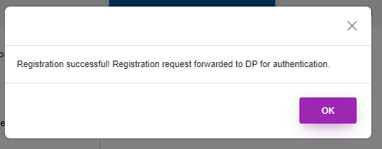

Trusted Account Addition for Early pay-in🡪1208750000001671

For Early Pay-in always change PIN🡪Miscellaneous🡪Change PIN🡪Enter Old pin and set new Pin

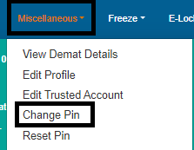

For Early Pay-in Transaction🡪Setup🡪Bulk Setup🡪Click on Early Pay-in

