**Pledge request from Client Login**

**Go to kedia capital site🡪https://kediacapital.com/🡪Client login🡪Back office login**

**Enter client code and Password and login**

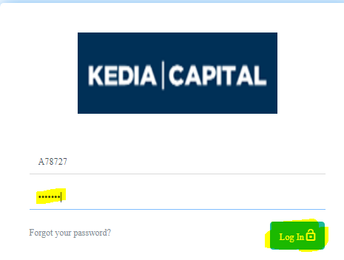

**On right side 🡪Request🡪select Margin Pledge🡪Click on Process showing Transaction ID**

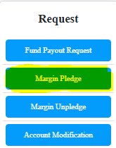



**Enter QTY then process and received Transaction ID after this process we will received pledge request in back office.**

**If you do not pledge selected scrip the click on cancel request.**

**After received request we will pledge on before 2.30pm.**